In order to actually submit for Cyber Essentials you will need to enter your responses on the IASME Portal: https://portal.iasme.co.uk/
Your username and password will each have been sent to you separately.

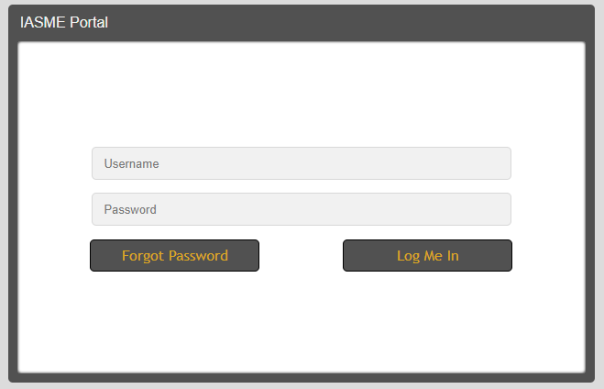

It is likely your username will be a form of your school name.
Your password will be a mixture of upper/lower/special characters.

You may have to wait briefly while the session loads.

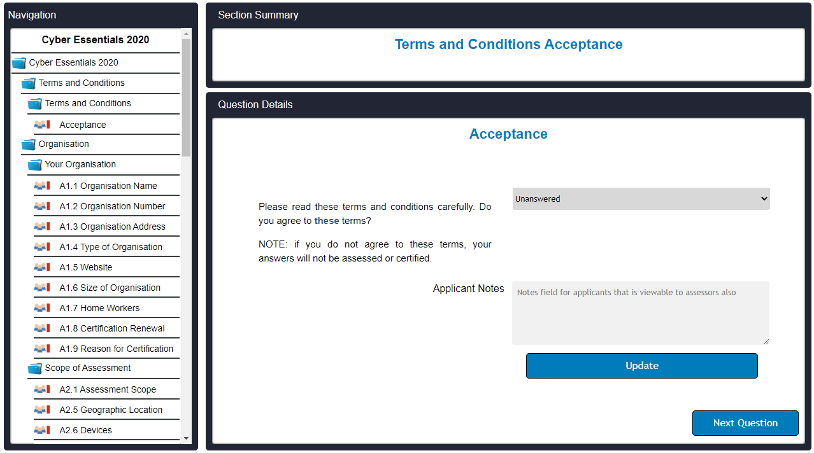
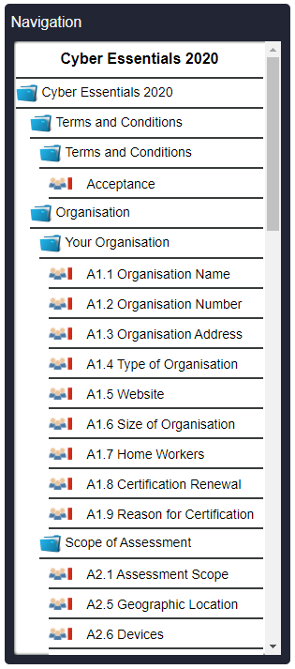
The navigation box allows you to go to a specific question.

The questions are sorted into the following sections:

Terms and Conditions
Organisation
Scope of the Assessment
Secure Business Operations
Office Firewalls and Internet
Secure Configuration
Patches and Updates
Access Control
User Accounts
Administrative Accounts
Malware and Technical Intrusion
Malware Protection
Assessment Complete
Attestation (Declaration)


Clicking the [update] button will save your responses on the platform.

Clicking the [next question] button will move through the questions in order.

For each question you will be able to choose you answer from the drop down box.
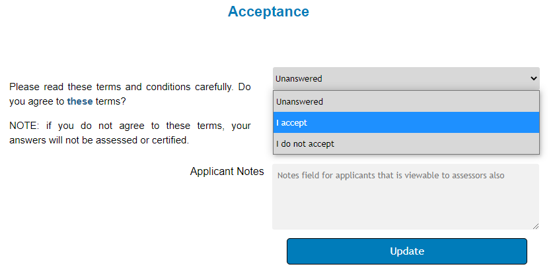
Use the Applicant Notes box if you want to share any additional information with the assessor.

When you have completed the submission, go to the top of the page and click [Export Answers].

A message will appear at the centre of the bottom of the screen 

This will be followed by

These answers need to be provided to the governing body or delegated governor representative.

Once they are confirmed as accurate, the governor representative should sign the insurance declaration.

When you are ready to send the submission to the assessor, click ‘Submit Answers’.

